**In Class Activity 3**

**Directions:** Write your code without the for loop and with the for loop

1. Create 8 sided octagon using turtle. Note that the angle of each point in a polygon is 45 degrees.

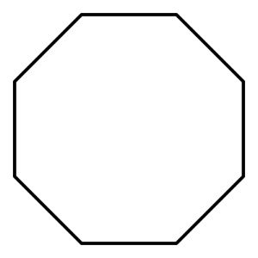

1. Make a turtle and set its color using the color method. Then write statements to have the turtle trace a five-pointed star. This will require 5 copies of a move forward followed by a turn. Note that the angle of each point in a five-pointed star is 36 degrees.

Then, add to your script a second turtle. Use the goto method to move the second turtle to a new location (remembering that (0, 0) is the position where the turtles start). Then have the second turtle draw another five-pointed star, in a different color just after the first turtle has drawn its star.

1. Create your own graphics using turtle.
2. (Optional)  
   Using nested for loop create the following pattern

*

**

***